Create new parts in Fritzing

Table of Contents
SVG Editing Tool 1
Create a Template from an IC 4
Fritzing File format 8
The XML file 9
Breadboard SVG 11
Changing the PCB Layer 19

There are a lot of instructions on the YouTube but none I could follow to create a new part for the MT6701 that was good enough for my project. In some cases, the InkScape software were a newer version and didn’t have the same functionality, in other cases, the fonts and colours that Fritzing accepts could not be replicated in the .svg file created by the vector software and the solution ended up to be saving the files as a different SVG file format.
So this is a comprehensive step by step instructions with example files of how to create a part from scratch in Fritzing.

SVG Editing Tool

InkScape is a freeware from Softonic that I used.

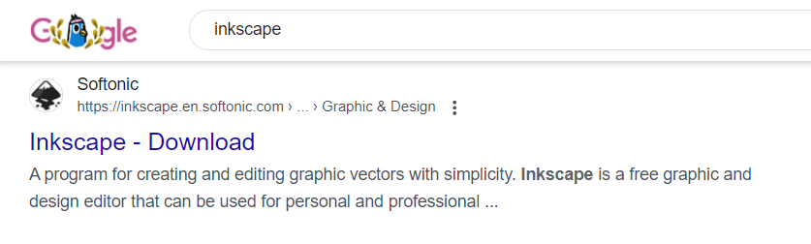

Download and install. I used the Windows version in English V1.3.2.

One problem with InkScape is that the default save is ‘Inkscape’ version of SVG and is not the format that Fritzing finds it easy to use with rendering some parts of the image.

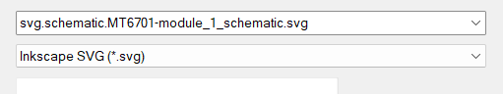

In some cases the solution was to use ‘Save As’ and select Type: Plain SVG.

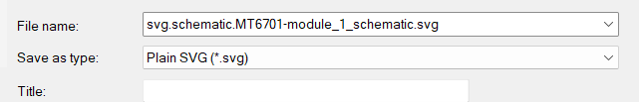

However in some other cases where the bitmap is traced, you may need to Save as Optimized type and select the correct settings

There are a lot of options to go through to optimise, I didn’t really have time to play with these settings.

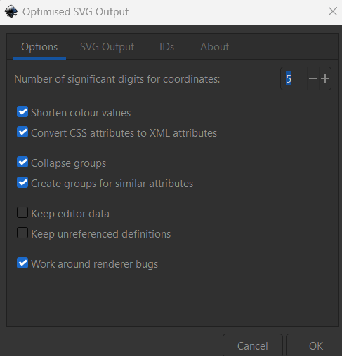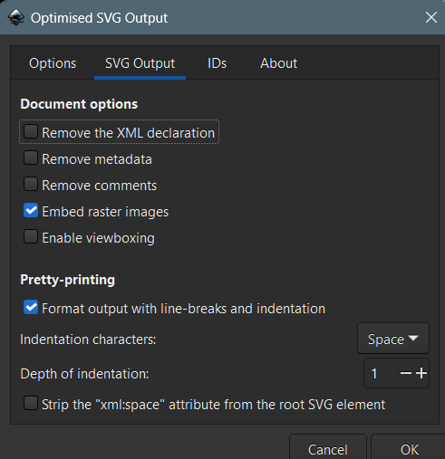

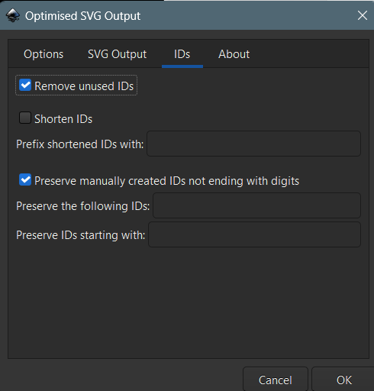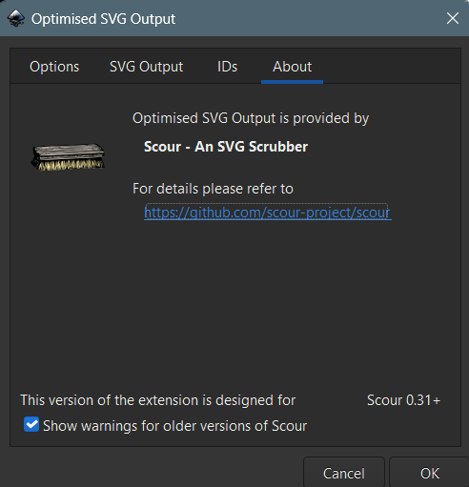

The main issue with using Inkscape was the rendering part of image and fonts.
The font issue is more likely the dimension and fill parameter which could be edited in the xml editor within Inkscape. If the font elements include dimensions in “px” units, it causes Fritzing to displayed the text at the wrong size.
The FritzingCheckApp application can help with that. Running the svg file that was saved from Draw through the tool will cleanup a lot of the problems. However a quick fix is to delete the values of font-Size if in px and fill value.

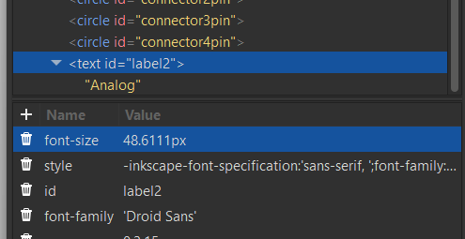

Open the XML Editor (Edit – XML Editor), Delete the font-size in px.by clicking on the bin.

The colour change may not work if it is fixed value in XML and you need to delete the line.

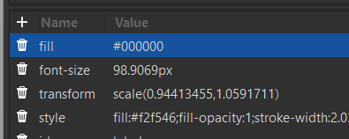

The above parameter makes the text appear black in Fritzing regardless of the actual text colour viewed and saved in Inkscape and you need to delete it.

Create a Template from an IC
If there isn’t a similar part, you need to create the initial template using an IC in Fretzing. This makes the life very easy a bit later.

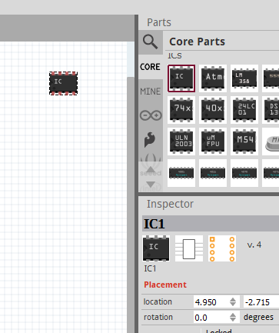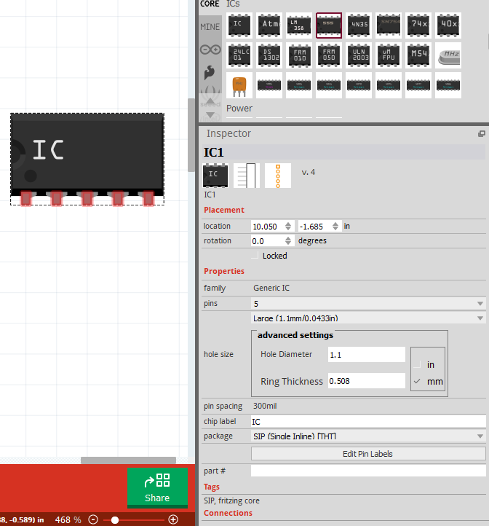

Go to Core parts and drag the IC into your workspace.

Do not scroll your mouse roller in the Inspector window (use the side scroll bar instead) as it select a Variant and won’t allow you to change it back and you have to start from scratch.

You need to make this as close as what you need in terms of number of Pins, labeling the Pins, pins in the correct order etc. so in the case of MT6701, we need 5 pins which are inline.
Pin 1 – VCC, Pin 2 – GND, Pin 3-Analogue, Pin 4-SCL, Pin 5-SDA.

Change the package to SIP (Single Inline THT)
Change the number of pins to 5 and leave other parameters such as pin hole size etc as they are.

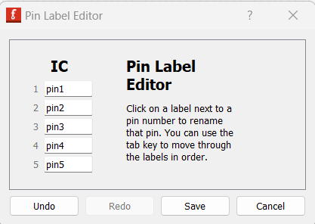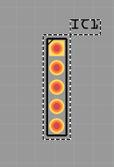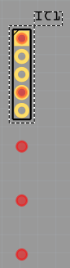

Look at the PCB layer to make sure that the pin spacing is correct. In a few occasions when changing the Hole diameter to 1.1, it seems that the spacing gets twice as many as it changes ‘in’ to ‘mm’

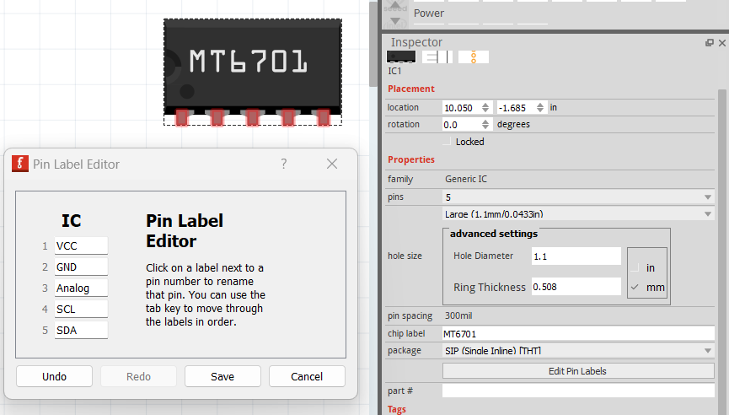

Now change the Chip Label to the new component (in this case MT6701) and click on the Edit Pin Labels and change Pin 1 to Pin 5 to what they actually are on the new component.

Now that the main pins are correct right click and enter the Edit mode – Edit(new parts editor)
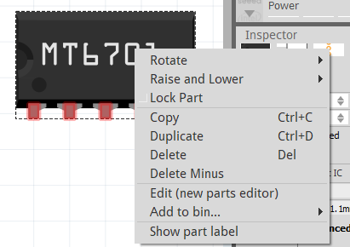

Click on the Metafile tab and change it to the new components

The ‘Template’ is nearly complete as the Schematic, PCB, Metadata (the xml file) and Connectors should all be correct.

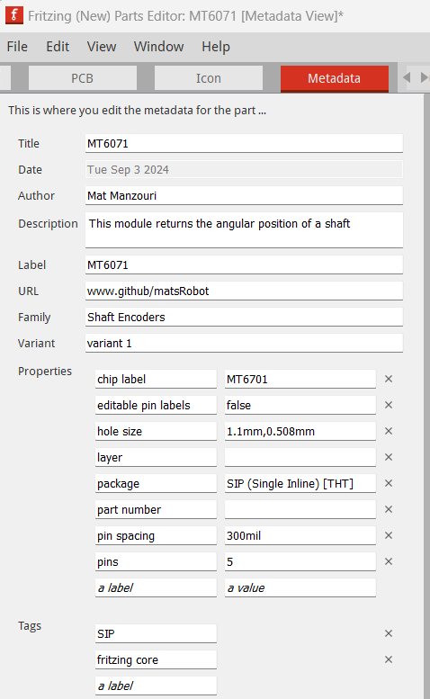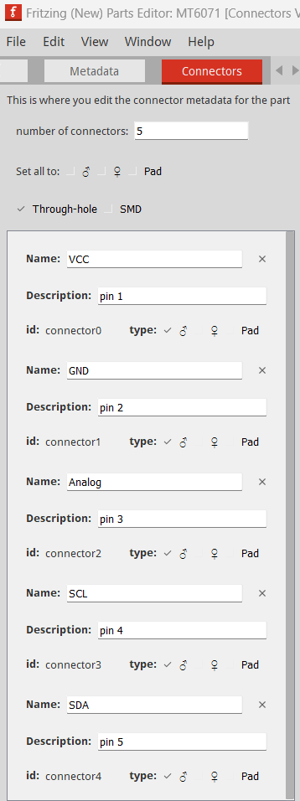

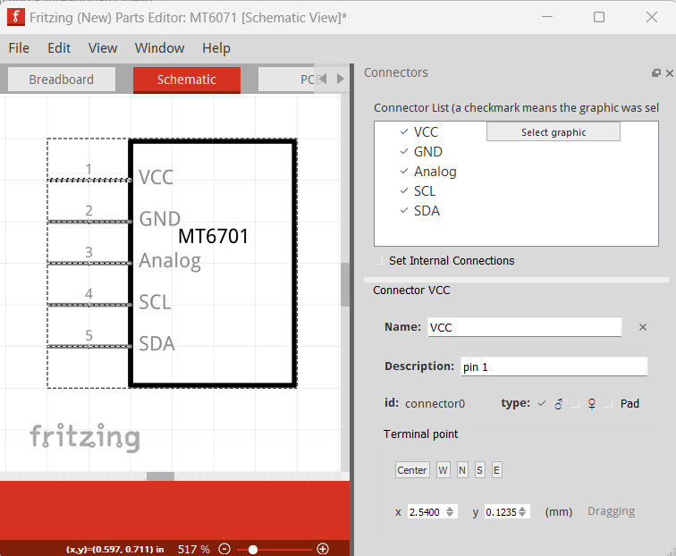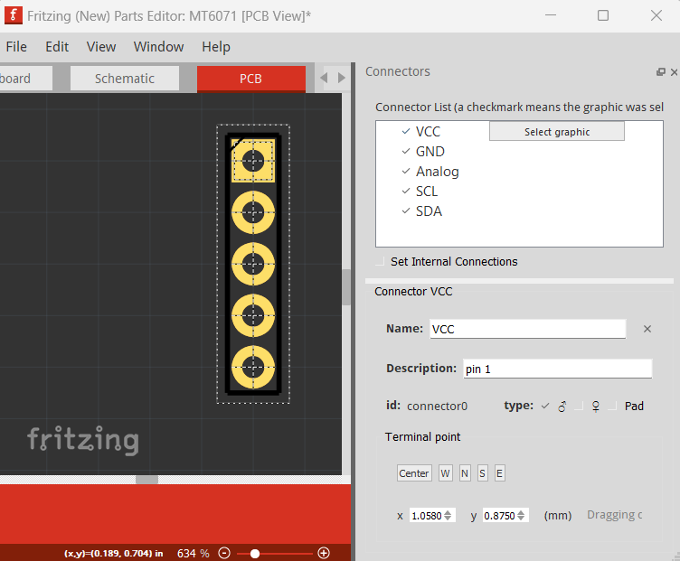

Save it as a New Part – File, Save as a new part. Prefix it as your new part.

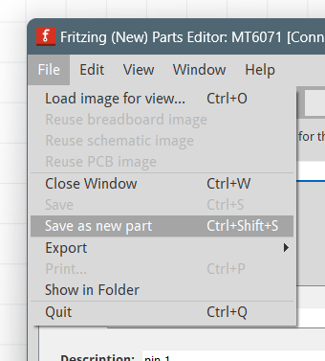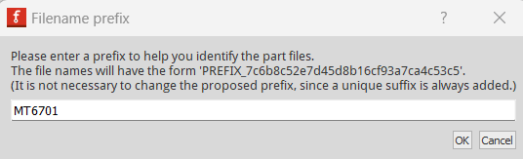

once you click ok, it would take you back to normal Fritzing page.

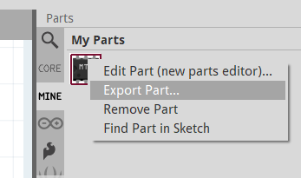

Now right click the part and Export it to your desktop.

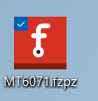

This generates the template that you need which is almost complete. It still needs the Breadboard svg and the Icon svg files which could be the same file.

Fritzing File format

As I was trying to see what works, I made a couple of batch files to rename it back and forth between .fzpz and ,zip.

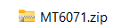

Once renamed the fzpz to zip you can open it and there are four files in there.

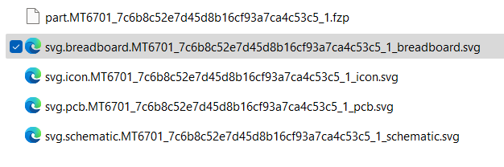

Rename all of these files by replacing the long random number with the word ‘Module’.

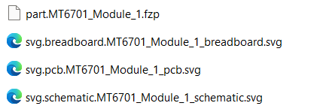

You also need to change the names in the XML file .fzp

The XML file

The next is to edit the fzp file which is an xml to reflect the new names.
I used Notepad+ + for editing

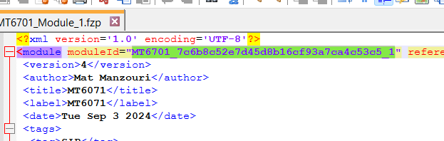

You need to change all instances of the large random number that Fritzing named your part to a new one, but make sure it is unique.

In this instance we are changing
‘MT6701_7c6b8c52e7d45d8b16cf93a7ca4c53c5_1’
to
‘MT6071 – Module_1’ through the xml file.

So in effect you need to find and replace ‘7c6b8c52e7d45d8b16cf93a7ca4c53c5’ with the word ‘Module’

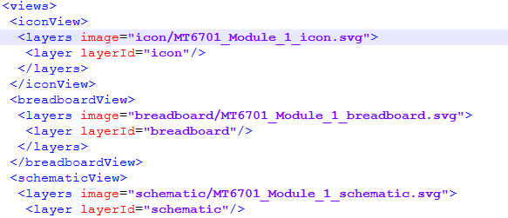

If you are using the breadboard.svg as the icon, you need to change the icon image file name accordingly.
"breadboard/MT6701_Module_1_breadboard.svg"
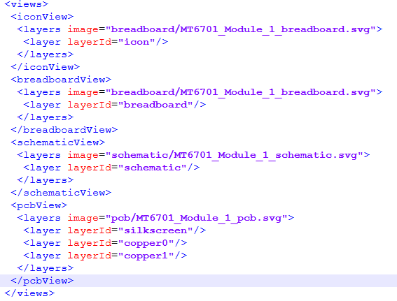

Now recombine and make sure it is all working ok before altering the svg file.

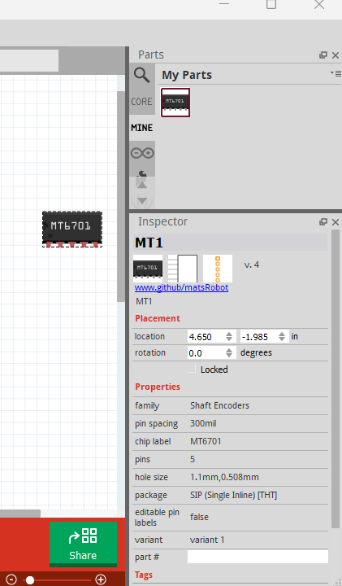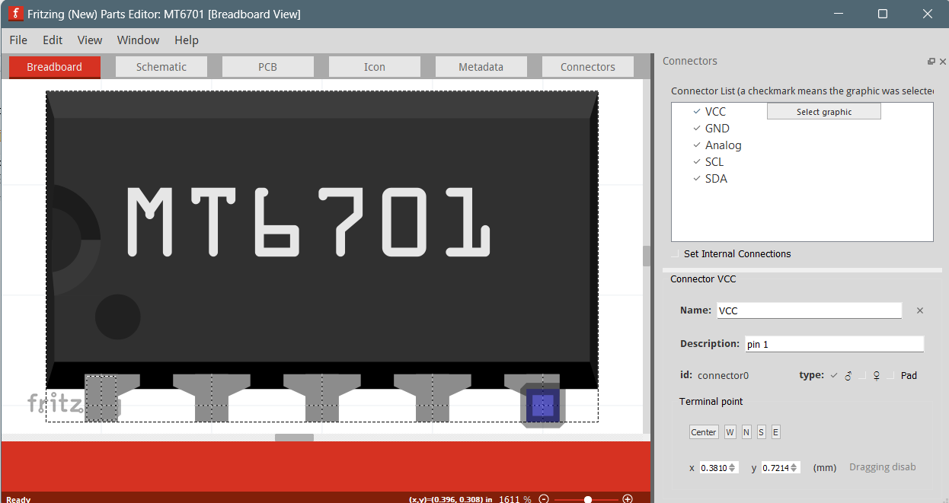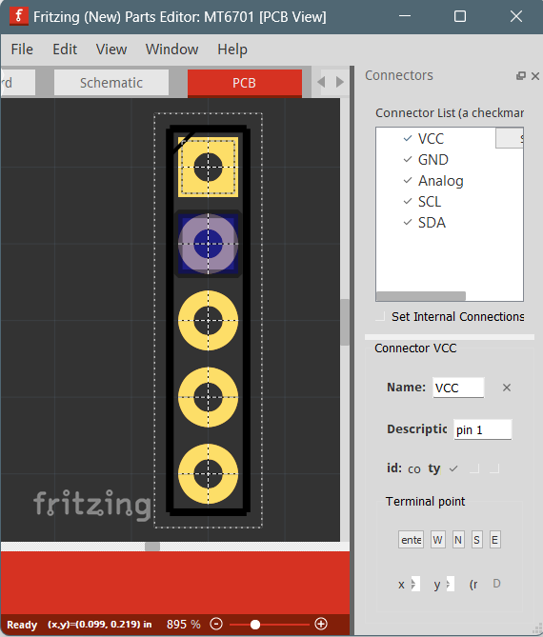

Apart from the functionality of the part try to edit it and see if the pins have tick against them on Breadboard and PCB and you can select the pins. You need to do this at every stage as this is the main symptom when something is not right.

Breadboard SVG

1- create a 500 pixel width of the image you want to be on the breadboard in Plaint packages. This could be an edited version of an image from the internet.

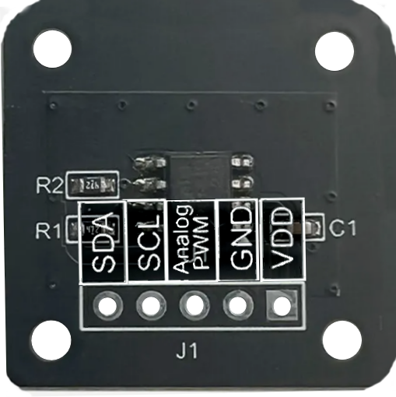
You may need to place the labels and other text within your image to avoid using fonts that may not be supported by Fritzing at later time.

Also clear out all the pins and make them very clear by making them white.

Start with the ‘svg.breadboard.MT6701-module_1_breadboard.svg’ as this is the most time consuming one.
So open it in InkScape.

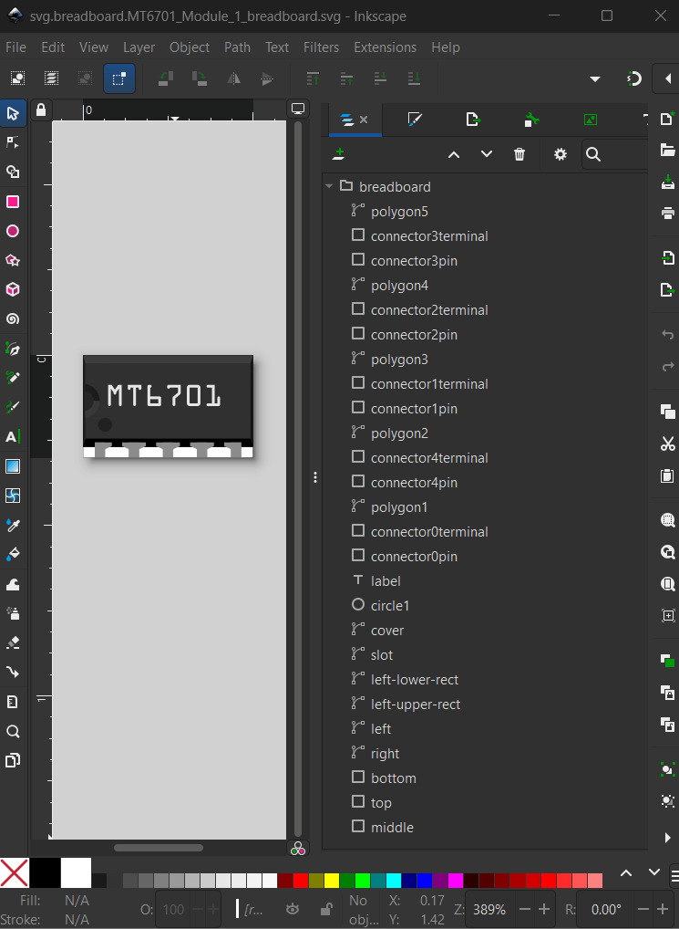

If you select ‘Layers and Objects’ 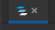 and drop down on >breadboard, you see all the vectors (components) of that object. If you scroll down to the end there is an object called Upper which is the background item. You need to replace these objects with your image, so delete all the other objects apart from those you want to keep.

In this example I’ve deleted everything apart from the lable

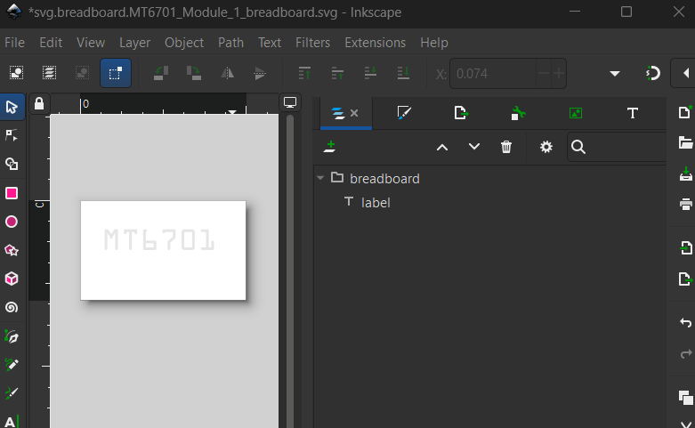

Open the ‘svg.pcb.MT6701_Module_1_pcb.svg’ in Inkscape, it opens another instance of Inkscope, highlight the connector pins including the square for Pin 1 and copy them to your clipboard.

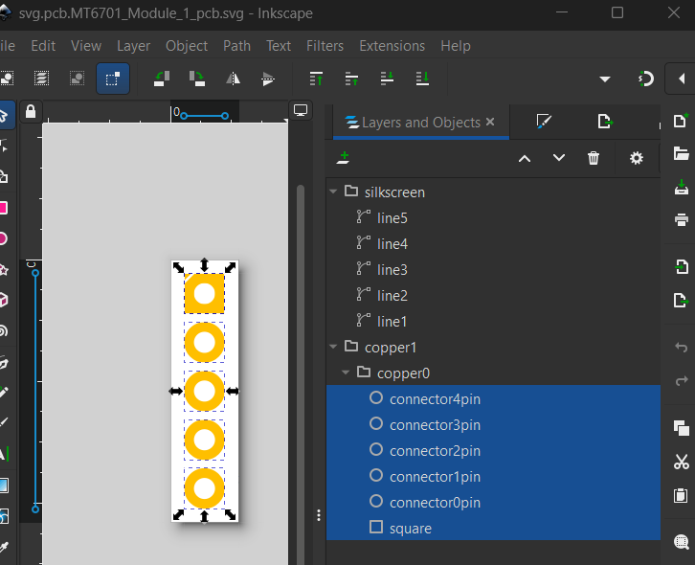

Now highlight the ‘label’ and paste them into the breadboard Inkscape file.
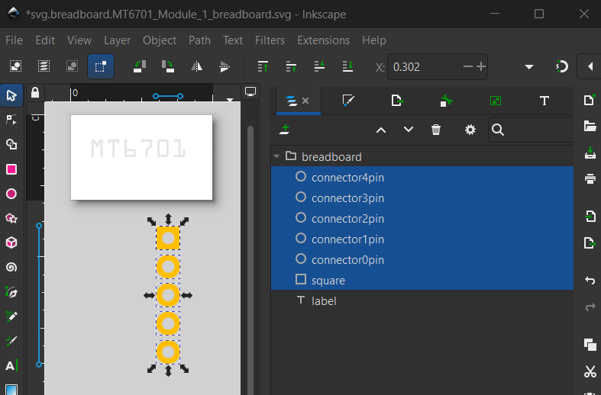

Turn the pins clockwise by clicking and position them in the parts space

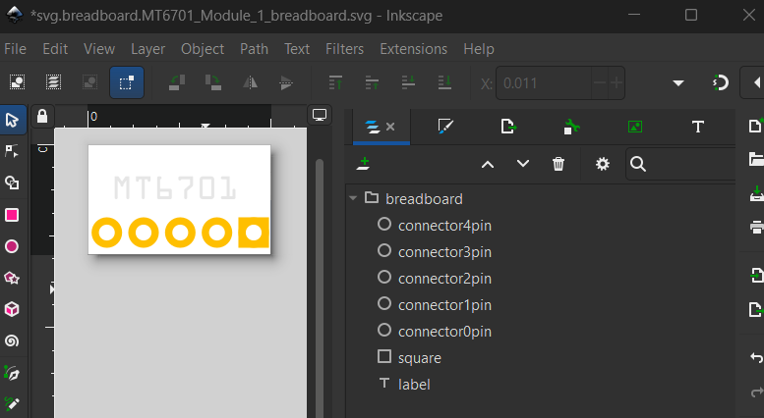

Ensure that Connector orders are correct and Connector0 is the square pin.

Right click on the part space and select document properties

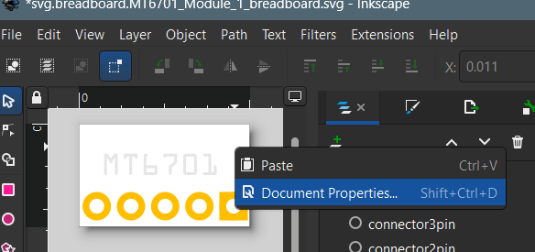

Change the size of the part to the measured value. (in this case 0.916 in)

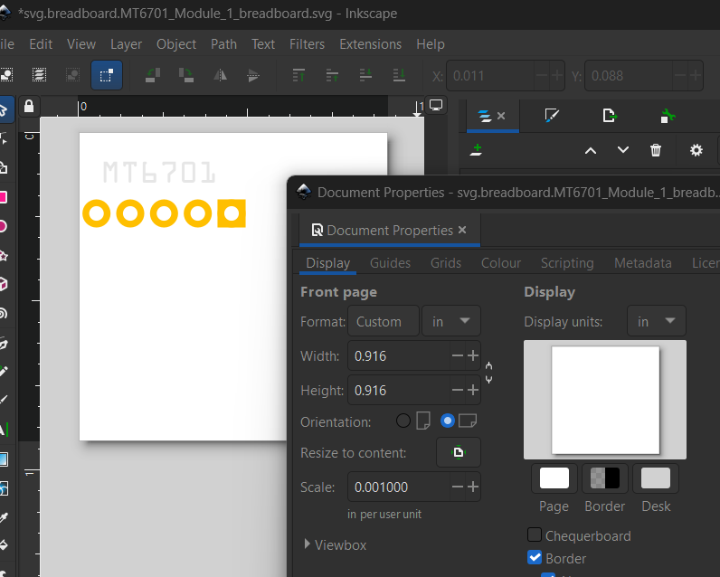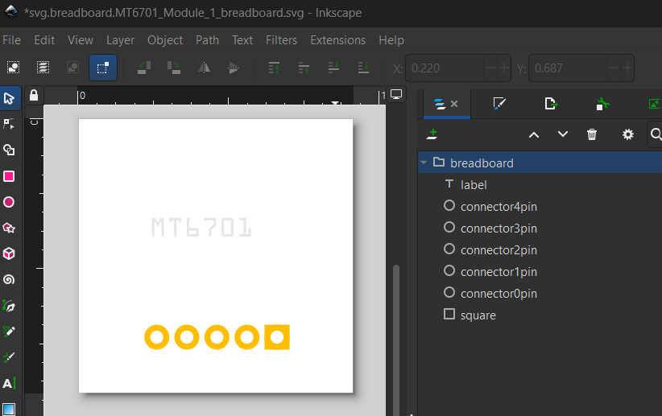

Now import the prepared bitmap image.

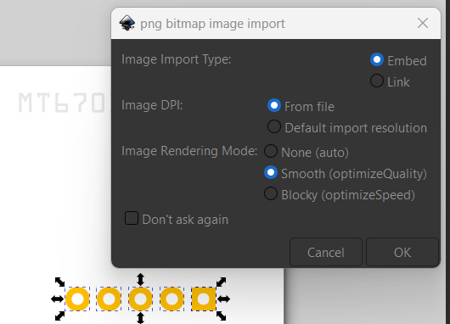

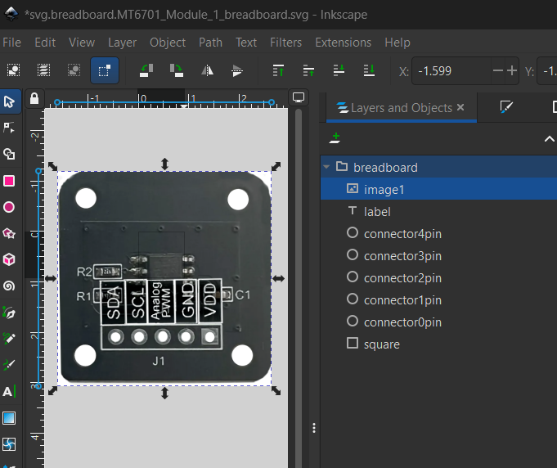

Now as the image is selected change its size at the top of the screen to the part size (in this case 0.916 in)
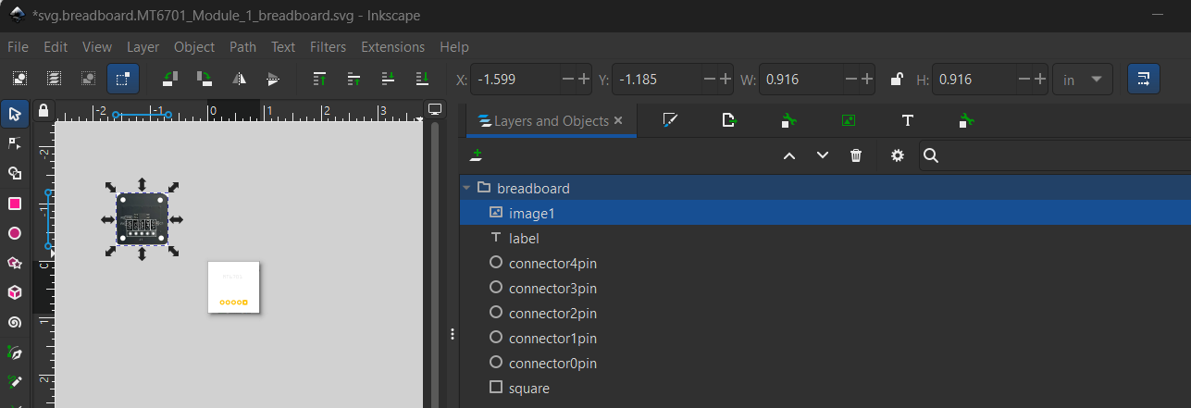

The image needs to be in the background so move it to the bottom of the list and move it the centre of the part area and position the pins to match the image.

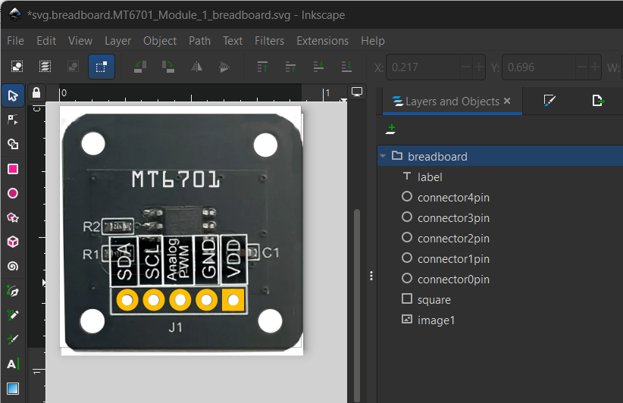

Now select the image and Trace Bitmap. If you keep the original image, Fretzing accepts it but it doesn’t allow you to save it as another part for future work as it cuts the image out.

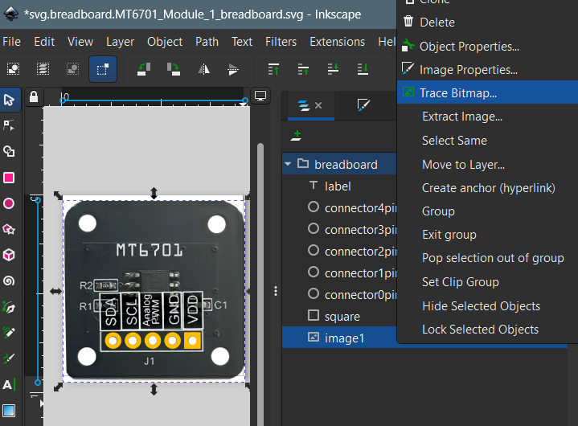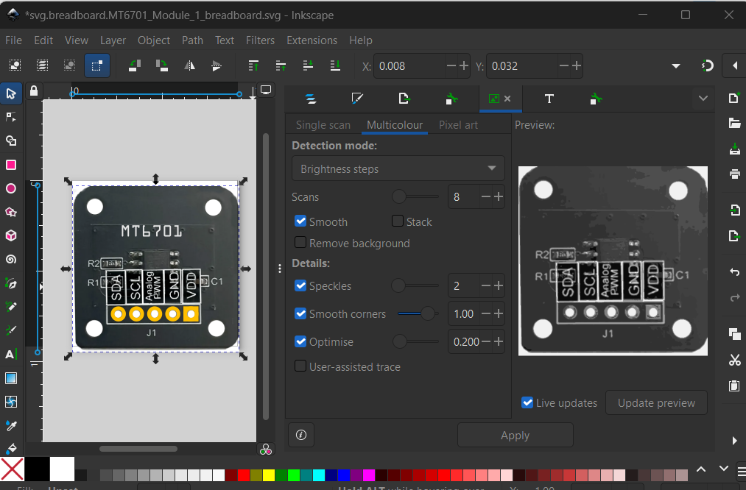

The simplest one is a single scan and set threshold to suit, but the image would not be very good.

The multicolour option is good and you need scans of 8 to 20 and then Apply, however if you do this you need to save the image as Plain and not the Inkscape format.

Now you can select the original image and delete it.

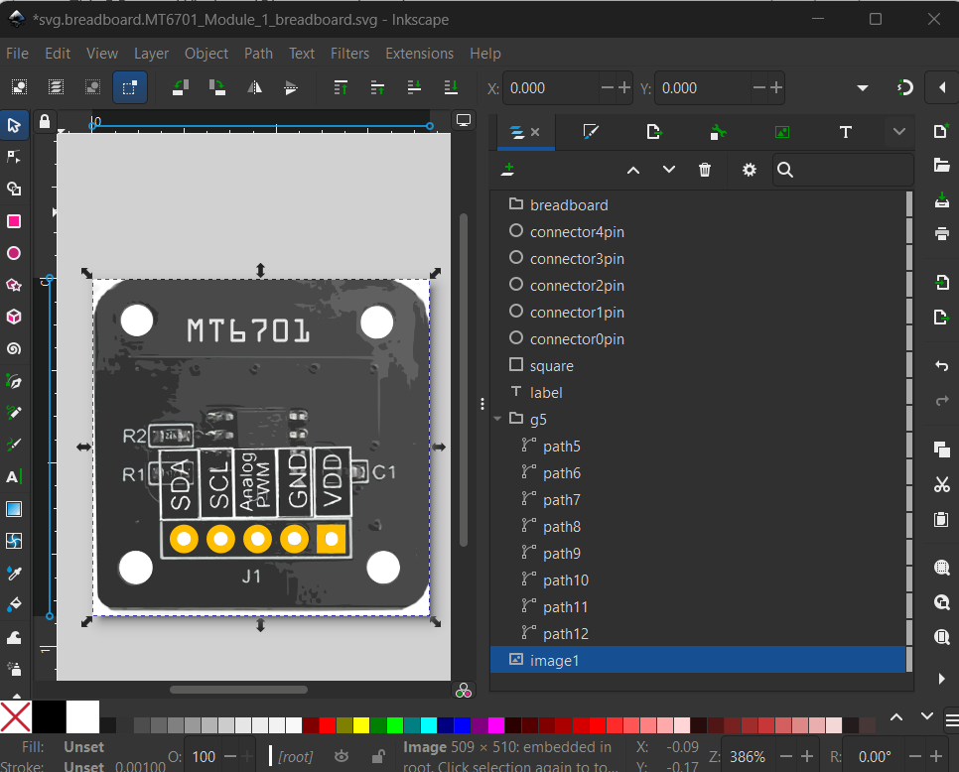

Fritzing is not working with all fonts, make sure that the label is using either OCRA or Droid Sans Mono

Now select the lable, go to Edit and select the XML editor
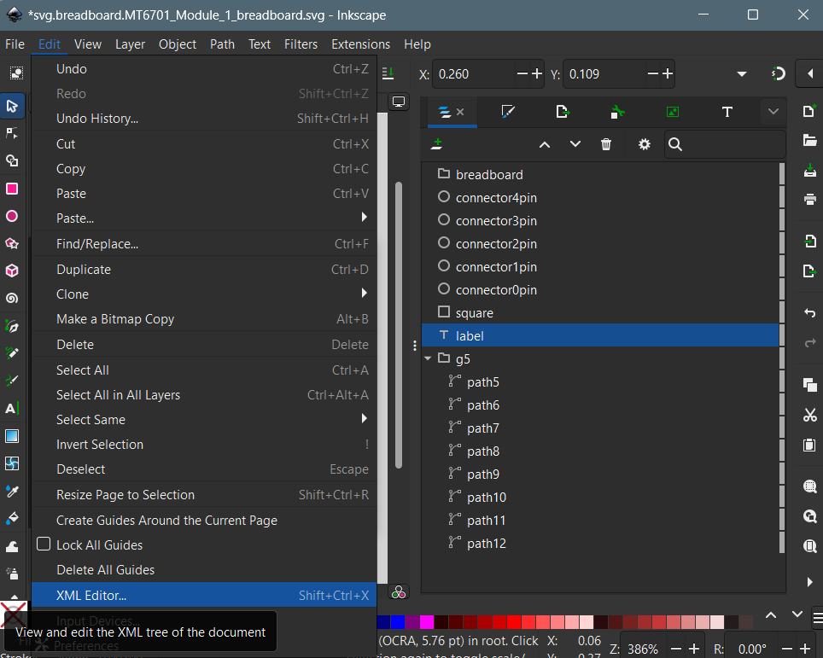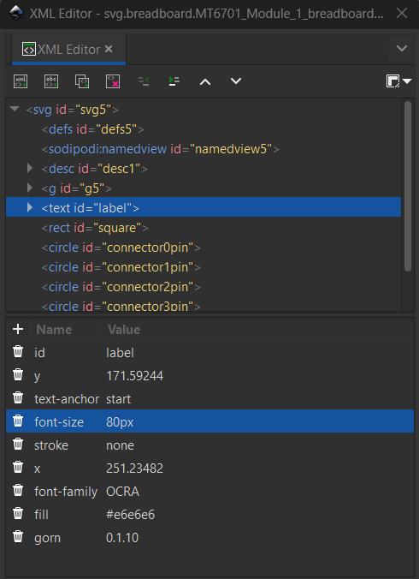

This shows you the Font size in px (pixels), which is not compatible with Fritzing, click the bin and delete it.
You may also want to delete the fill if you chose to change the colour of the font-size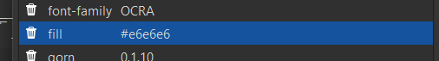
Now you need to resize the font as it shows it very small. So press the T icon, on Font Tab change the font size and Apply.
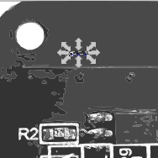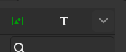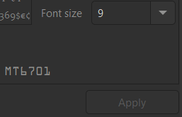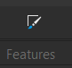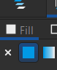

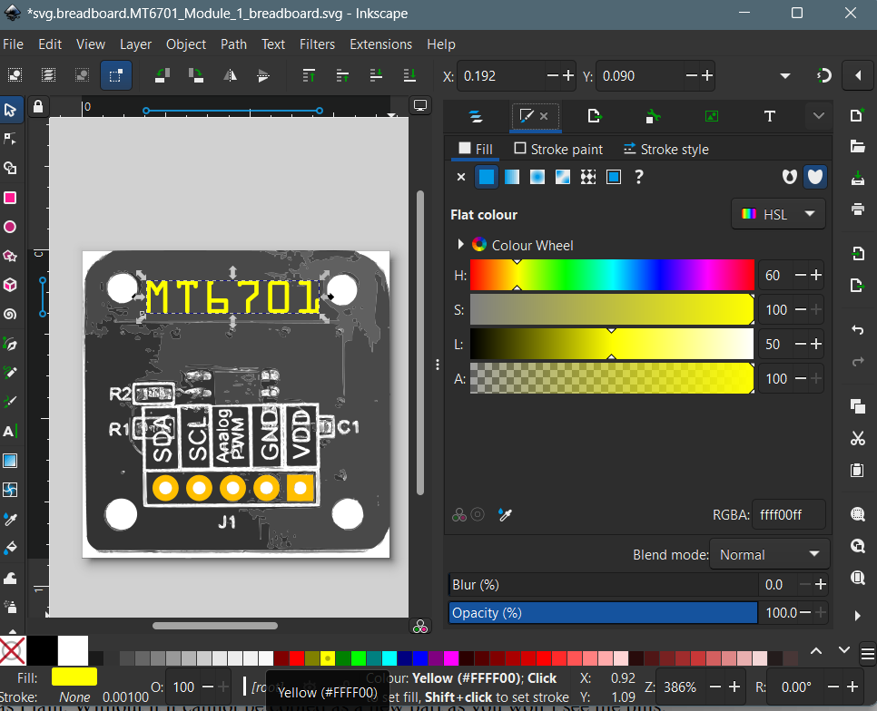

Now save as Plain. Without it it cannot be copied as a new part as you won’t see the pins.

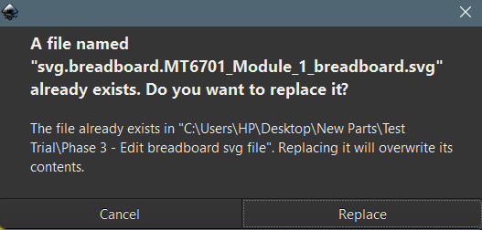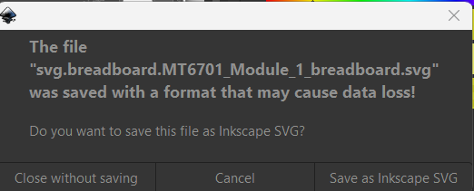

Click Replace, but when you close Inkscape you need to select Close without saving as you have already saved it as Plain SVG format.

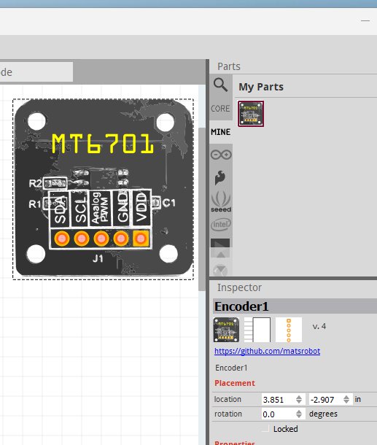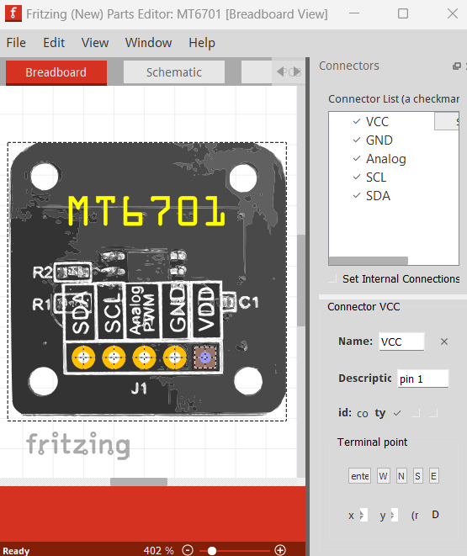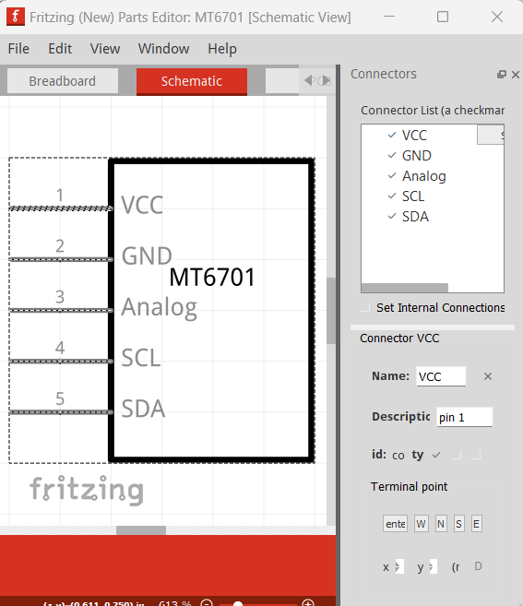

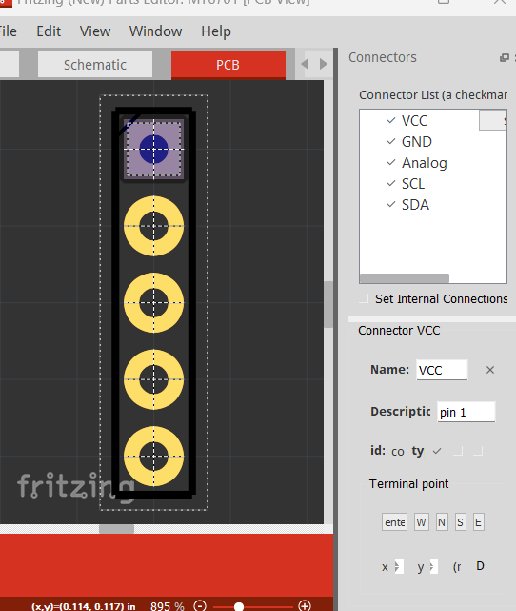

The breadboard view should be working in Fritzing and in the edit mode all the pins should be ticked and it should be all complete.

If you need a different PCB layout then follow the next stage.

Changing the PCB Layer
To edit the PCB layout, open the ‘svg.pcb.MT6701_Module_1_pcb.svg’ file in Inkscape.

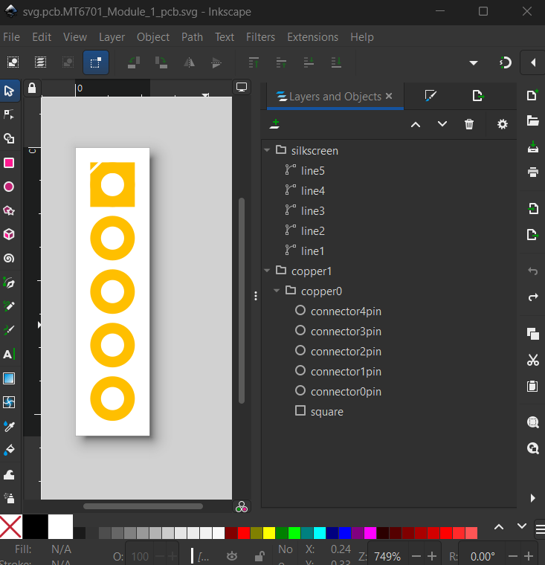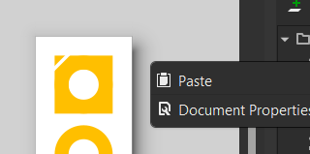

Start with that was generated by the IC

Use page properties to make it 0.916x0.916 in

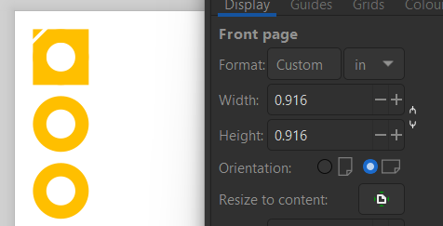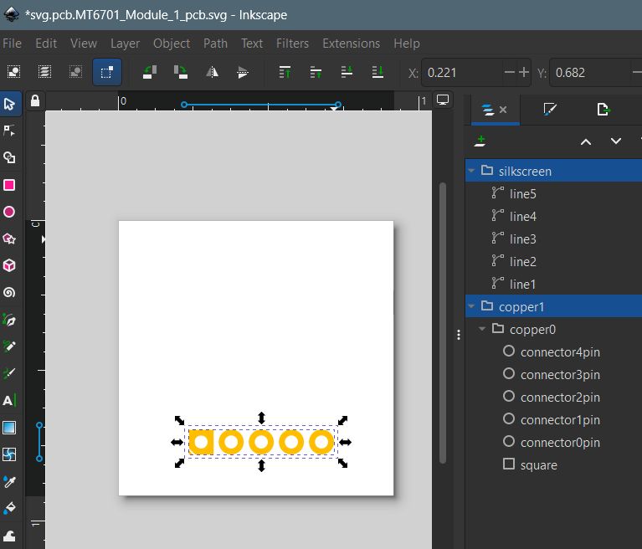

Delete the lines and add 4 Circles (copied from another PCB layer) and also the TopMask on the silk layer, and again copied from somewhere else.

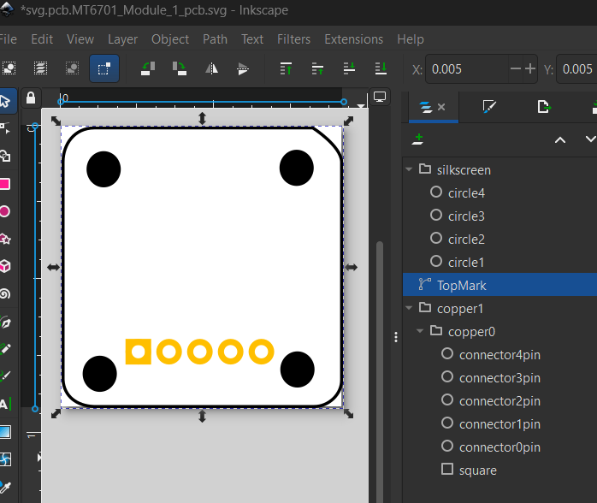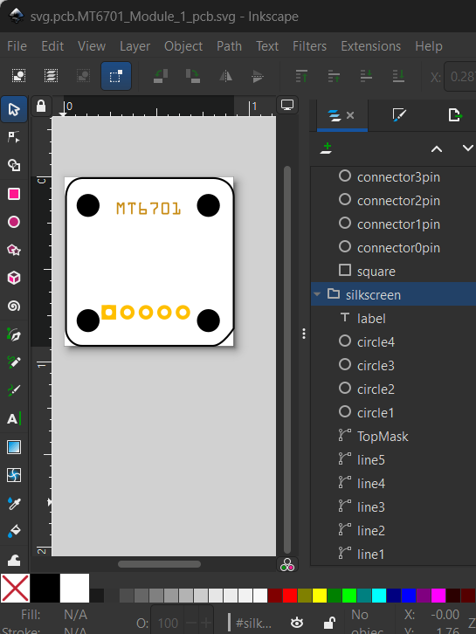

The order of layers is very important as it won’t create a new part. Make sure that the copper pins are first and then the silkscreen with the topmark as the last item.

Now Save As ‘Plain SVG’ type and make sure that it works in Fretzing.

